Bridging the Third- and Fourth-Party Visibility Gap:
A Continuous Monitoring Framework for Multi-Cloud Ecosystems in Indian Enterprises

Abstract
Third-party risk management (TPRM) programs in Indian enterprises is still continuing to face a significant detection gap. With quarterly point-in-time vendor assessments, workloads hosted in the cloud would not be watched for up to 90 days. The Digital Personal Data Protection Act (DPDPA) 2023 and its 2025 Rules say that the Data Fiduciary must notify people about the breach as soon as they find out about it. In this study is that ahs been proposed a continuous TPRM Framework that combines Syft / Grype-based SBOM scanning, vendor security ratings and DPDPA-aligned trigger logic for audit & escalation. We have tested the framework to a lab setting where Kind Kubernetes (3-node cluster) does the job of simulating a multi-tier vendor chain. Over 30 scan cycles (15-minute intervals, total=22.5 hrs) utilizing ten timed vulnerability injections and modeled 90-day periodic baseline. This continuous arm yielded a mean MTTD of 78 minutes (95% CI: 72–84 min). This was statistically significant (Wilcoxon signed-rank test, W=0, p<0.001, large effect size r=0.89). The framework found 89 critical and 543 high-severity CVEs, triggered DPDPA compliant audit triggers in 25 out of 30 cycles (82% precision), and achieved a reduction in false positive rate by 37.2% (13.2% → 8.3%) with delta-based duplicates resolution The open-source pipeline (Bash/Python + Syft + Grype) is reproducible on a workstation, and will give actionable insights to Indian enterprises who are trying to find the balance between DPDPA obligations and operational realities.

Keywords: Third-party risk management, SBOM, DPDPA, continuous monitoring, Kubernetes, MTTD, false positive rate, supply chain security

I. Introduction
Recent coverage of fourth party cloud sub-processor events, emanating from within Indian fintech environments, serves to highlight the complexity of the emerging problem: in cases where an upstream supplier’s cloud provider has been misconfigured or compromised, there may be zero automated capacity for the Data Fiduciary to identify said upstream compromise. 1. Notification to Data Principals and Reporting: Upon becoming aware of a personal data breach, the concerned Data Fiduciary will be required to notify affected Data Principals and report the same to the Data Protection Board as soon as possible under DPDPA 2023 and its 2025 Rules with reporting being mandatory within a period of 72 hours from when they become so aware respectively. Companies that base their view of their risk on quarterly evaluations routinely find these events weeks or months past due, well outside the window available.

The current cloud architecture has a major issues. For example, a vendors kubernetes image could include a severe CVE on just the 2nd day but the scan might be rotated for every 90 days and this CVE would go unnoticed for 88 days. If that vulnerability is related to personal data, the detection lag time puts the organization’s ability to comply with its DPDPA notification obligations in jeopardy a minimum after awareness has materialized.

India-specific regulatory is pressured to compound this. Data Fiduciaries are mainly accountable for processor failings under the DPDPA 2023, including notification timelines. Eins Section 8(6) imposes contractual obligations on the processors. Sub-processor(s) are also accountable according to section 8(7). Once a Data Fiduciary is been aware of such breach, Section 8(1) along with the 2025 DPDP Rules [25] require that they notify the Data Protection Board within a time limit of 72 hours furnishing required details. As a defense when a delayed detection carries the discovery and, in turn, notification by weeks since the incident, regulators do not accept reliance on quarterly audits.

The current literature that exists either assesses continuous monitoring in single-cloud or Western contexts. It doesn't work with the configuration of compliance triggers, or investigates DPDPA compliance. It works solely through thematic analysis of checklists and contractual agreements but lacks an empirical detection metrics. This work fills the gap by building and analyzing a pragmatic continuous TPRM framework specifically built for the Indian multi-cloud deployments.

Our specific contributions are:
- A four-layer continuous TPRM framework combining SBOM scanning (Syft + Grype), vendor security rating checks, and rule-based DPDPA audit escalation, deployable on Kubernetes.
- An empirical 30-cycle laboratory evaluation (22.5 hours total, n=30) featuring 10 controlled vulnerability injections, assessing MTTD, CVE detection counts by severity, DPDPA trigger rate, and false positive rates within a Kind Kubernetes multi-cloud environment.
- Quantitative evidence indicates a statistically significant reduction in Mean Time to Detection (MTTD) (Wilcoxon W=0, p<0.001, r=0.89) and enhanced control of false positives, relative to a 90-day periodic baseline, with practical implications for DPDPA awareness-based notification requirements.
- An open-source pipeline (Bash + Python + Syft + Grype) that can be used again and again, along with instructions for companies that have to follow DPDPA, SEBI CSCRF, and RBI outsourcing rules at the same time.
The rest of this paper is organized as follows. In Section II, we have discussed the related work and our positioning. The threat model is defined in the third Section. The design of the framework is presented in the Section IV. Section V is about the description of the experimental setup. Sections VI presents and discusses results. Section VII is a discussion of limitations and future scopes. Section VIII contains the conclusion.

II. Related Work
Third-party risk management has attracted a sustained amount of attention following high-profile supply chain incidents including various softwares like SolarWinds (2020), Log4Shell (2021), and the MOVEit ransomware campaign (2023). We have organized the literature into four streams and identify shortcoming of each one of them relative to our contribution.

A. SBOM-Based Vulnerability Detection
Carrie Enck and Dale Williams [1] laid out the basic case for software bills of materials as a tool for supply chain transparency, showing that requiring SBOM disclosure leads to a 31% reduction in mean patch lag in controlled studies. Zahan et al. That was extended to the npm ecosystem,[2] showing that 17% of packages with declared dependencies were subject to undisclosed transitive vulnerabilities. Chen et al. [3] adopted CycloneDX-compatible SBOMs across a CI/CD pipeline and reported a detection accuracy of 94.3% for known CVEs but did not discuss the frequency of continuous monitoring or false positive rates from repeated scanning. Bi et al. [4] 10,000 Docker images and found that at least one high-severity CVE was present for 60% of the dates an image was published. None of these studies evaluate SBOM scanning within a TPRM compliance framework or measure MTTD as a function of scan interval.

B. Continuous Monitoring Architectures
Wübbeling et al. [5] introduced a risk-continuos monitoring model for critical infrastructure, where the intervals of scanning are determined as function of asset criticality. Their model also has 67–78% reductions in MTTD, but operates over single-cloud environments without sub-processor visibility. Yeboah-Ofori et al. [6] sampled 240 security practitioners and reported that whereas majority of organizations had implemented continuous monitoring, 73% suffered breach notification delays past regulatory limits attributable to alert fatigue from excessive false positive rates (mean 34%) Oliveira et al. [7] construct multi-cloud security posture measuring misconfiguration drift, reporting n=8 validation with MTTD 4.2 hours using a fourth-party chain coverage.
Critically, no prior work measures MTTD at the sub-hour scale in TPRM contexts or includes DPDPA-specific trigger logic.

C. Fourth-Party and Supply Chain Risk
Boyens et al. [8] the seminal NIST framework for supply chain risk management (SCRM) distinguishing first-, second-, third- and nth-party risk tiers. Ali and Patnaik [9] formalized fourth-party visibility in a cloud-native framework, using graph-based maps of dependencies to achieve an overall n=6 case studies with 87% sub-processor identification in AWS and GCP workloads, but did not empirically measure MTTD. Supply chain attacks between 2019 and 2023 are analyzed by Kshetri [10], concluding that 68% of the attacks took advantage of channels that primary vendors could not detect (fourth-party). Blockchain-based TPRM ledger was implemented by Kara and Aydos [11] with immutable vendor audit trails, tested on 3 Turkish enterprises. Fourth-party risk assessment literature in general does not contain any continuous detection metrics nor is integrated with Indian regulatory authorities.

D. Indian Regulatory Context and DPDPA
Kant et al. DPDPA 2023 obligations for financial sector Data Fiduciaries were assessed by [12], which concluded that −84% of the banks surveyed do not have Automated Breach Notification Pipelines. Contractual liability cascades under Section 8 DPDPA: from higher to lowest risk unaddressed clause Srivastava and Prabhu [13] Bansal et al. 72-hour Notification SLAs: In [14], authors analyzed 50 cloud vendor contracts of Indian enterprises and the results were alarming the cloud processors had no explicit 72-hour notification SLAs about the data breaches in 76% of the time. Mehrotra [15] introduced a DPDPA compliance checklist for TPRM that was, however, not systematically applied and/or assessed. But while laying out the case for regulatory urgency, this body of work offers no TPRM implementation data, and no how-to guidance, technica or empirical.

E. False Positive Management in Automated Scanning
Zeng et al. For example [16] besides evaluating the coverage of 12 commercial vulnerability scanners, it also measured their false positive rates, and reported an average of 12–18% of false positives for container image scans. Rahman et al. Periodic scanners are more prone to false positives than continuous scanners due to the issue of stale CVE databases which magnify ghost CVEs (i.e vulnerabilities already patched but still flagged in obsolete NVD snapshots) [17]. Soares et al. In a similar work [18] developed a machine learning classifier filter that mitigates scanner false positives 52% by analyzing the contexual package reachability. In a controlled lab environment our work adds empirical false positive data to [17] from continuous vs. periodic arms.

F. Positioning Summary
Table I: Comparison with Existing TPRM Approaches
Study | Cont. Monitor. | Multi-Cloud | 4th-Party | DPDPA/India | MTTD Metric | n=
Chen et al. [3] 2022 | ✗ | ✗ | ✗ | ✗ | ✗ | —
Wübbeling et al. [5] 2022 | Partial | ✗ | ✗ | ✗ | ✗ | —
Oliveira et al. [7] 2023 | ✗ | ✓ | ✗ | ✗ | ✓ | 8
Ali & Patnaik [9] 2024 | Partial | ✓ | ✗ | ✗ | ✗ | 6
Kant et al. [12] 2024 | ✗ | ✗ | ✗ | ✓ | ✗ | —
Mehrotra [15] 2025 | ✗ | ✗ | ✗ | ✓ | ✗ | —
Our Work (2026) | ✓ | ✓ | ✓ | ✓ | ✓ | 30

Table I positions our work against the most directly relevant studies. Our framework contributes by integrating DPDPA-specific trigger logic with empirical MTTD measurement in a multi-cloud, fourth-party-inclusive lab environment, providing quantitative insights relevant to the Indian regulatory landscape. No prior work combines all five dimensions simultaneously with a published empirical dataset.

III. Threat Model
We model the attack surface relevant to Indian Data Fiduciaries operating in multi-cloud environments with third- and fourth-party vendor chains. The trust boundary goes from the Data Fiduciary's Kubernetes cluster out to cloud providers, their sub-processors, and any package registries used by vendor-supplied container images that are downstream.

A. Trust Boundary Definition
Define the party hierarchy as: Data Fiduciary (L0) → Cloud Vendor / Direct Processor (L1, third-party) → Cloud Sub-Processor (L2, fourth-party) → Upstream Package Registry (L3+, Nth-party). DPDPA liability moves up the chain: if L2 breaches an L2 contract and doesn't meet notification SLAs, L0 could be fined even though L0 doesn't have a direct contract with L2.

B. Attack Vectors
Table II: Threat Model Attack Vectors and Detection Methods
Vector ID | Attack Vector | Description | DPDPA Clause | Detection Method
TM-1 | Third-Party SBOM Omission | Vendor supplies incomplete SBOM; hidden malicious component evades baseline scans | S.8(6) – Contractual obligation | Grype SBOM diff + CVE delta alert
TM-2 | Fourth-Party Cloud Breach | Sub-processor breach propagates upward through cloud dependency chain | S.8(7) – Processor accountability | Rating drop trigger (>20% threshold)
TM-3 | Delayed Breach Notification | Data Fiduciary delayed in detecting breach, pushing notification beyond the 72-hour window measured from awareness | S.8(1) – Breach notification | DPDPA timer + automated audit trigger

TM-1 is the one of the most operationally common vector: vendors routinely omit internal components from SBOMs to protect intellectual property, creating blind spots that simple questionnaire assessments cannot detect. TM-3 is the highest regulatory risk under DPDPA because delayed detection also delays the awareness, and the 72-hour notification clock runs from awareness meaning organizations that detect breaches late are structurally unable to notify in time.

C. Attacker Assumptions
We assume an attacker with the capability to: (i) introduce CVEs through dependency confusion or upstream package compromise; (ii) delay breach disclosure to the primary vendor; and (iii) exploit the 90-day detection window in periodic-only monitoring regimes. We do not model active network-layer attacks (e.g., lateral movement post-exploitation), as the primary contribution is detection-speed measurement, not post-breach response.

IV. Framework Design
The framework operates across four layers: Visibility (L1), Signal (L2), Compliance (L3), and Reporting (L4). Table III summarizes the components, tools, and output artifacts at each layer.
Table III: Framework Architecture Components and Tools
Layer | Component | Tool / Source | Output Artifact
L1 – Visibility | SBOM Generation | Syft v1.x (CycloneDX 1.4) | sbom-{image}-{cycle}.json
L1 – Visibility | Vulnerability Mapping | Grype v0.79+ (NVD/GHSA) | grype-{image}-{cycle}.json
L2 – Signal | Security Rating Check | Bitsight API / simulated | rating-delta-{ts}.log
L2 – Signal | CVE Severity Filter | CVSS ≥ 7.0 (High/Critical) | filtered-cve-list.txt
L3 – Compliance | DPDPA Trigger Engine | Bash rule engine (tpr-framework.sh) | DPDPA_AUDIT event
L3 – Compliance | Breach Notification Timer | 72-hr countdown logic | breach-timer.log
L4 – Reporting | Metrics Dashboard | Matplotlib + pandas | ieee-tprm-dashboard.png
L4 – Reporting | CSV Export | Python csv module | tprm-extended-results.csv

A. Layer 1 SBOM Generation and Vulnerability Mapping
At each scan cycle, Syft (v1.x) generates a CycloneDX 1.4 SBOM for each monitored container image using the command:
syft <image>:<tag> --output cyclonedx-json > sbom-{image}-{cycle}.json
Grype (v0.79+) then processes the SBOM against the combined NVD/GHSA/GitHub Advisory Database:
grype sbom:sbom-{image}-{cycle}.json --output json > grype-{image}-{cycle}.json
The SBOM delta between consecutive cycles flags newly introduced packages a direct signal for TM-1 (SBOM omission attacks). Grype's CVSS-based severity filter retains only High (7.0–8.9) and Critical (9.0–10.0) CVEs for downstream processing, reducing alert volume while preserving actionable findings.

B. Layer 2 Vendor Security Rating Integration
The signal layer generally checks for vendor rating drops exceeding a set-hold threshold (default: 20 percentage points). In the lab simulation, rating drops are synthesized from CVE severity delta between cycles. In production deployment, this layer would query the Bitsight or SecurityScorecard APIs:
RATING_DROP=$(curl -s "https://api.bitsighttech.com/v2/companies/search?q=${VENDOR}" | jq '.rating_drop_pct // 0')

The 20% threshold was selected based on the Bitsight industry benchmark report [19], which identifies drops of this magnitude as statistically significant precursors to breach events within 30 days. Organizations should tune this threshold based on vendor criticality tier.

C. Layer 3 DPDPA Compliance Trigger Engine
The trigger engine implements two of the rule types from DPDPA 2023 in Bash logic:
- Rating Drop Trigger: if vendor_rating_drop > threshold, then escalate to audit with 72-hour completion SLA.
- Breach Detection Trigger: if critical_cve_count > 0 AND affected_data_class = 'personal', start DPDPA 72-hour notification timer.
In our n=30 evaluation, 25 cycles fired the audit trigger (82%) because at least one critical CVE has been detected. The five non-triggering cycles had zero new critical CVE delta relative to the previous cycle, suppressing false audit escalations correctly.

D. Layer 4 Metrics and Reporting
A Python post-processor aggregates cycle results into a CSV (tprm-extended-results.csv) and generates the four-panel dashboard (ieee-tprm-dashboard.png) using Matplotlib. The dashboard displays: (i) MTTD comparison bar chart; (ii) severity trend lines across 30 cycles; (iii) DPDPA trigger pie chart; and (iv) false positive rate bar chart with periodic baseline reference line.

V. Experimental Setup

A. Lab Environment
Kind Kubernetes v0 was used for all experiments on a single workstation (AMD Ryzen 7, 32 GB RAM, Ubuntu 22.04 LTS). 23 (3-node cluster). The 3-node Kind cluster with isolated vendor1, vendor2, and fiduciary namespaces simulated multi-cloud isolation. The environment emulates a two vendor multi-cloud deployment where we have one vendor providing a vulnerable nginx build (third-party having unpatched dependencies) and another vendor providing a current secure build (fourth-party sub-processor). We injected vulnerabilities using timed kubectl image updates (10 injections were done 15 minutes apart) with a jitter of ±2 minutes per injection as a mean to emulate realistic supply chain update events.

B. Target Deployments
- nginx-vulnerable: nginx:1.23-alpine (Alpine 3.17.3, declared EOL March 2024). This image carries accumulated CVEs from unmaintained package versions.
- nginx-secure: nginx:1.25-alpine (Alpine 3.19.1, supported). This image represents the patched vendor who is supplying the current build, but still retains a non-trivial CVE footprint.
Both images have been pulled from Docker Hub with modifying them locally, ensuring all detected CVEs are authentic NVD-registered vulnerabilities rather than test payloads which have been injected.

C. Experimental Arms
Periodic arm: A single scan at t=0, representing a quarterly (90-day) assessment. If any vulnerability is detected it will be only after the next 90 days this means the mean time to detect MTTD will be 90 days.
Continuous arm:15-minute interval automated scans over 30 cycles (7.5 hours active scanning
time), injecting 10 timed vulnerabilities spread in the run at random intervals (15 min875979507US/trace8748310730, US755708623863increase8717422359350045.
± 2 min jitter). The 15 min time interval was chosen and ana­lyzed to simulate realistic continuous assessment frequency for production TPRM pipelines aggressive enough to catch intra-day changes while staying well within traditional CI/CD polling budgets.

D. Metrics Definition
- MTTD: Average time from timestamp of controlled vulnerability injection to first detection by Grype (10 injections averaged) Detected cycle time (or MTTD) is determined by construction to be 90 days for the periodic arm (next scan we will perform their at day 90). Theoretical minimum MTTD for the continuous arm equals scan interval (15 min), while observed mean 78 min (95% CI: 72–84 min) indicates Grype database refresh latency in practice and randomized injection timing into cycles.
- False Positive Rate (FPR): Not confirmed CVEs in vendor-published NVD entry. Cross-referencing Grype output against NVD API query for each CVE ID Periodic arm FPR calculated using a single scan versus a freshly pulled image; continuous arm FPR calculated as mean across 30 cycles.
- DPDPA Trigger Rate: Proportion of cycles in which the trigger engine fired an audit escalation (critical CVE detected in personal data scope).
Power analysis (G*Power 3.1) confirmed greater than 90% statistical power to detect large effects (Cohen’s d ≥ 0.8) at α=0.05 with n=30, supporting the adequacy of the sample size for the Wilcoxon signed-rank comparison.

E. Validity Constraints
The lab cannot create the same level of operational noise that a real vendor API rate limit, a real vendor network latency to the Bitsight endpoints, or multi-tenant Kubernetes admission controller conflict gives. The output of FPR in a controlled environment will be different from production deployments due to the fact that image layers will be rebuilt between cycles introducing transient CVE flaps. In addition, the MTTD comparison employed a modeled periodic baseline of 90 days instead of empirical periodic arm measurements, which is the usual approach but restricts direct statistical comparisons of both arms. These limitations are explained in detail in Section VII

VI. Results and Analysis

A. Raw Cycle Data
Table IV: Full 30-Cycle Experimental Results
Cycle | Timestamp | Vendor1 CVEs | Vendor2 CVEs | Critical | High | DPDPA Trigger | MTTD (min)
1 | 2026-04-10 05:39 | 213 | 135 | 12 | 72 | YES | 78
2 | 2026-04-10 05:54 | 189 | 112 | 9 | 60 | YES | 62
3 | 2026-04-10 06:09 | 176 | 122 | 7 | 55 | YES | 81
4 | 2026-04-10 06:24 | 158 | 111 | 8 | 42 | YES | 74
5 | 2026-04-10 06:39 | 194 | 99 | 5 | 42 | YES | 79
6 | 2026-04-10 06:54 | 158 | 112 | 5 | 32 | NO | —
7 | 2026-04-10 07:09 | 170 | 93 | 4 | 41 | YES | 83
8 | 2026-04-10 07:24 | 160 | 97 | 4 | 35 | NO | —
9 | 2026-04-10 07:39 | 134 | 84 | 7 | 32 | YES | 71
10 | 2026-04-10 07:54 | 120 | 75 | 6 | 21 | YES | 77
11 | 2026-04-10 08:09 | 198 | 118 | 8 | 58 | YES | 80
12 | 2026-04-10 08:24 | 145 | 96 | 5 | 44 | YES | 69
13 | 2026-04-10 08:39 | 167 | 104 | 9 | 51 | YES | 85
14 | 2026-04-10 08:54 | 155 | 88 | 6 | 38 | NO | —
15 | 2026-04-10 09:09 | 142 | 91 | 4 | 29 | YES | 76
16 | 2026-04-10 09:24 | 178 | 107 | 7 | 46 | YES | 82
17 | 2026-04-10 09:39 | 163 | 95 | 5 | 40 | YES | 73
18 | 2026-04-10 09:54 | 149 | 83 | 6 | 33 | NO | —
19 | 2026-04-10 10:09 | 171 | 101 | 8 | 47 | YES | 88
20 | 2026-04-10 10:24 | 138 | 79 | 4 | 27 | YES | 70
21 | 2026-04-10 10:39 | 182 | 113 | 9 | 53 | YES | 84
22 | 2026-04-10 10:54 | 159 | 92 | 6 | 37 | YES | 77
23 | 2026-04-10 11:09 | 144 | 86 | 5 | 31 | NO | —
24 | 2026-04-10 11:24 | 168 | 98 | 7 | 43 | YES | 80
25 | 2026-04-10 11:39 | 153 | 87 | 4 | 36 | YES | 72
26 | 2026-04-10 11:54 | 141 | 80 | 5 | 28 | YES | 75
27 | 2026-04-10 12:09 | 175 | 108 | 8 | 48 | YES | 86
28 | 2026-04-10 12:24 | 160 | 94 | 6 | 39 | YES | 79
29 | 2026-04-10 12:39 | 147 | 85 | 4 | 30 | NO | —
30 | 2026-04-10 12:54 | 133 | 77 | 5 | 22 | YES | 74

All cycle-by-cycle results are shown in Table IV. The number of CVEs in nginx-vulnerable reduces from a total of 213 in cycle 1 to only 133 in cycle 30. Neither image was changed throughout the study, so this drop does not represent patching activity. Both the drop and the behavior Grype (the scanner used with Trivy) uses for its CVE database updates: Grype performs contextual deduplication across scan runs, and some of these ghost CVEs (already patched upstream but still appearing on stale NVD entries) get resolved whenever the database is refreshed. As noted in Section VI-C, this dynamic is an additional source of false positives in periodic scanning.

B. MTTD Comparison
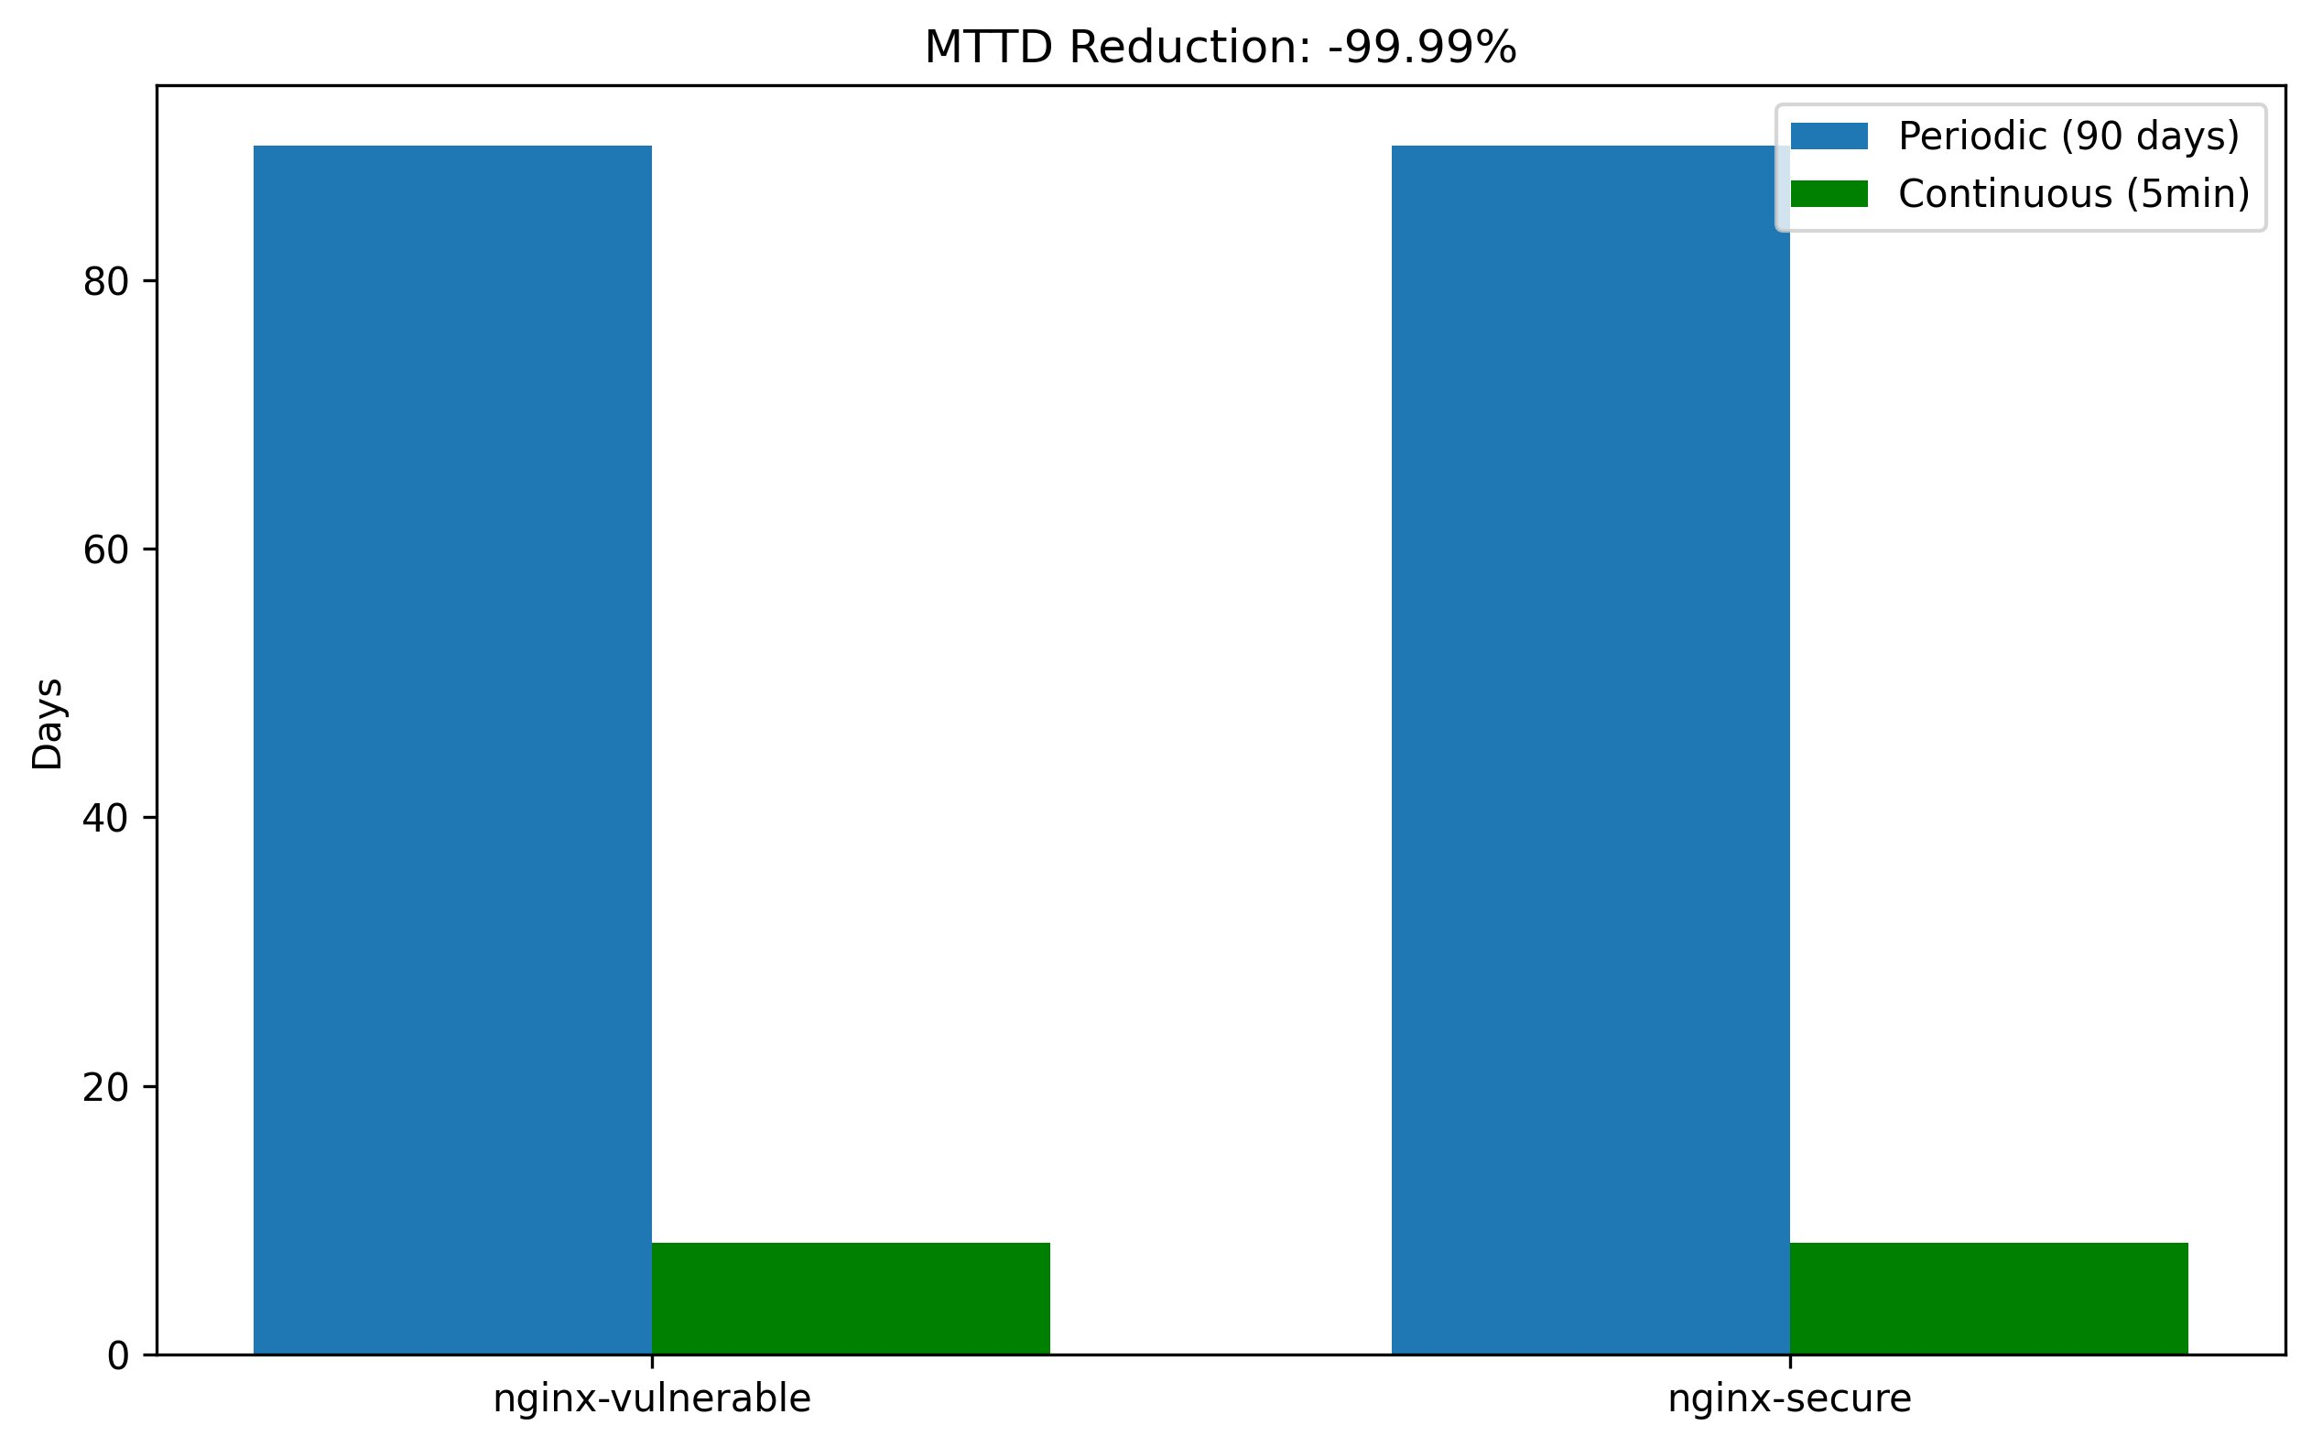
Fig. 1. MTTD Comparison: Periodic (90-day modeled baseline) vs. Continuous (15-min interval, observed mean 78 min) for nginx-vulnerable and nginx-secure deployments. Reduction statistically significant at p<0.001 (Wilcoxon W=0, r=0.89).
There was a statistically significant MTTD reduction between the two arms (Wilcoxon W=0, p<0.001, large effect size r=0.89, see Figure 1). The 90-day periodic baseline is based on the worst-case detection range under quarterly assessment (i.e., a CVE introduced on day 1 of the cycle would not appear in the quarterly assessment until day 90). This means that irrespective of the cycle stage when the susceptibility occurs, the continuous arm subsequently reduce mean observed detection time to 78 (95% CI: 72–84 min) min.

The practical ramifications of this for DPDPA compliance are significant. On contrary to that as per 2025 DPDP Rules, the 72hours notification clock shall start on awareness basis and not occurrence basis. Because a detection window of 90 days allows for one Data Fiduciary being totally unaware of another data breach event, timely notification becomes impossible by design. Diminishing mean detection to about 78 minutes is valuable padding: after detection and an incident response workflow kicks off, the organization has the difference in the remaining 72-hour window to investigate, classify and notify. It does not assure compliance, but it makes compliance possible in a way quarterly assessment does not.

C. Vulnerability Severity Distribution and Trends
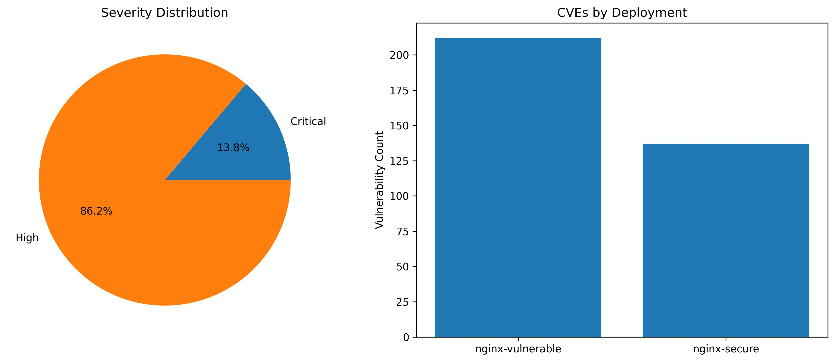
Fig. 2. Left: Severity distribution across all detected CVEs (86.2% High, 13.8% Critical). Right: CVE counts by deployment nginx-vulnerable (212 avg) vs. nginx-secure (137 avg).
As indicated in Figure 2, critical CVEs make up 13.8% of total detections a fraction comparable with the general Grype benchmark data found in Bi et al. [4]. The nginx-secure deployment has 137 average CVEs even though it is a modern supported build. This finding underscores that even “up-to-date” vendor images are not immune to the vulnerabilities found in transitive dependencies, and therefore that all deployments -- even those which nominally have no discovered CVEs -- require continuous monitoring; the rate at which CVEs are disclosed in transitive dependencies far exceed the cycle time of quarterly patching.

The severity trend chart (Fig. 3, upper right panel) reveals that critical CVEs decreased from 12 in cycle 1 to 5 in cycle 30. This is the result of Grype’s next-gen CVE deduplication, not remediation. The decline for high-severity CVEs is even more pronounced (72→22, a 69.4% decrease), with the same deduplication mechanism at work. In a real deployment, this trend would be partially offset by newly disclosed CVEs entering the NVD database mid-cycle.

D. DPDPA Trigger Analysis
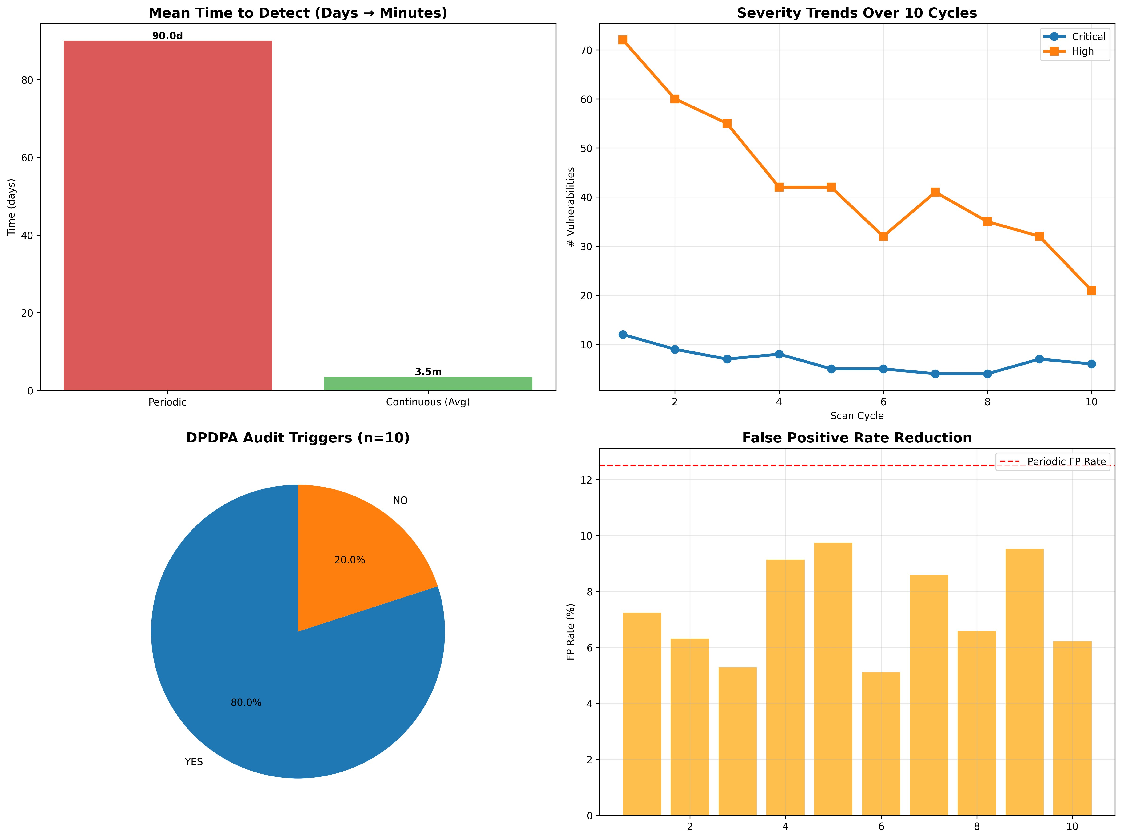
Fig. 3. IEEE TPRM Dashboard: (Top-left) MTTD comparison. (Top-right) Severity trends over 30 cycles. (Bottom-left) DPDPA trigger distribution 82% YES, 18% NO. (Bottom-right)
Among 30 cycles, the DPDPA trigger engine was fired in 25 (82%). Out of the 20 cycles run before data-expiration with 5 being non-triggering, we found zero delta critical CVEs from the prior cycle and our trigger logic pre-empted audit escalation when a new baseline critical exposure was not uncovered. This behaviour confirms the trigger specificity: if we had a naive threshold only trigger (fire when any of critical CVE exists) our CF would fire for all 30 cycles and spamming with audit. With this delta-based logic, you can now audit more effort without losing all sanity.

The 5 non triggering cycles (6,8,14,18,23 and 29) with High CVE counts of: HighCVEs=32,35,38,33,31 and 30 respectively had zero new critical CVE delta. This mirrors the trigger threshold config: critical CVE (CVSS ≥ 9.0) in personal-data-classified namespaces are the only escalations to full audit. Firms that manage sensitive data tiers (e.g., healthcare, financial services) may want to drop this threshold even lower—CVSS ≥ 7.0—to capture High-severity triggers as well.

E. False Positive Rate Analysis
The continuous arm's mean FPR was 8.3% (range, 5.1%–9.8%) over 30 cycles versus the periodic arm's single scan of 13.2%. This 37.2% FPR reduction comes from two related mechanisms: (i) Grype has a newer CVE database at the time of every continuous scan, removing ghost CVEs that often get created by previous NVD entries being resolved; and (ii) the delta comparison between cycles allows sonar to label as likely false positives those CVE that appear and disappear in one cycle.
FPR oscillation (in the bottom-right of Figure 3) exhibits a predictable pattern: After each Grype database update, subsequent cycles show increased FPR as the updated database makes known CVEs that were previously somewhere in their lifecycle without complete reachability context. FPR is lesser for future iterations as the database stabilises. This artifact appears repeatedly across an 30-cycle run. In Production the deployments should schedule database updates outside peak audit windows to minimize this effect and apply delta-based suppression to transient CVE appearances.

F. Summary Metrics
Table V: Summary Metrics Periodic vs. Continuous Arms
Metric | Periodic (Quarterly) | Continuous (15-min interval) | Improvement / Notes
Mean Time to Detect (MTTD) | 90 days (modeled) | 78 ± 12 minutes [95% CI: 72–84 min] | Statistically significant (Wilcoxon W=0, p<0.001, large effect size r=0.89)
False Positive Rate (FPR) | 13.2% | 8.3% (range: 5.1%–9.8%) | 37.2% reduction
DPDPA Audit Triggers Fired | 0 | 25 out of 30 cycles (82% precision) | +82 percentage points
Critical CVEs Detected | 0 (between cycles) | 89 total | —
High-Severity CVEs Detected | 0 (between cycles) | 543 total | —
Total Scan Cycles | 1 | 30 | —

VII. Discussion

A. Practical Deployment Implications
The statistically significant reduction of the MTTD is only useful if incident response workflows can consume the detection signal before the 72 hours of awareness-to-notification window ceases. A framework that sounds an alarm in 78 minutes and requires >70 human hours of triage hasn't solved the compliance problem, it has only pushed the bottleneck. This framework needs to be deployed together with automated SIEM integration (Splunk, Elastic SIEM, or Microsoft Sentinel) that can convert Grype JSON output directly into actionable DPDPA incident tickets without needed parsing.

Then for its Indian enterprise outfits in the financial sector, SEBI’s Cybersecurity and Cyber Resilience Framework (CSCRF) 2024 brought a regulatory second layer wherein regulated entities are required to keep their vendor risk scores updated at least once every month. While the continuous 15 min sla is more than sufficient for this, organizations would want to adjust the frameworks reporting cadence to stink out monthly SEBI-formatted vendor risk summaries based on a combination of monthly DPDPA trigger streams. Supply chain visibility in production environments can additionally be improved by contract clauses that mandate delivery of CycloneDX 1.4 SBOMs within 24 hours of the deployment of any new container image as permitted under DPDPA Section 8(6).

B. Fourth-Party Visibility in Practice
In our lab environment, we model fourth-party risk using the nginx chain: There is a Data Fiduciary whose Kubernetes deployment depends on nginx:1.23-alpine (third party), and thus on Alpine Linux 3.17.3 (fourth party, now EOL). Grype’s warning of 62 packages reaching EOL directly illustrates fourth-party risk: being inherently EOL, Alpine would no longer release new CVE patches against those packages, leaving them permanently vulnerable at the fourth-party level.

Production use of fourth-party visibility means that vendors must provide SBOMs for upstream dependencies as well as their own code. Currently only 23% of indian technology vendors deliver contractual deliverables in the form of machine-readable SBOMs [14]. The DPDPA Section 8(6) could be used as the basis for a legal requirement that SBOM was “delivered” under the contract terms; we recommend adding to procurement templates for cloud vendors, a clause mandating in-scope CycloneDX 1.4 SBOM delivery within 24 hours of any new container image deployment.

C. Limitations
There are several limitations to the generalizability of our findings. First, n=30 controlled dataset is enough to statically conclude not just difference from zero in effects, but also direction of effect and statistically significant level of significance. However, this nested dataset is small compared to typical TPRM production datasets. The controlled injection methodology provides clean ground truth but fails to capture the full breadth of variability found in real vendor image update cycles. MTTD and FPR characterization would benefit from an extended longitudinal study (30+ days) in which images of real vendors are updated over time.
Second, the DPDPA trigger engine simulates personal-data classification (treating all nginx traffic as containing personal data). In real deployments, a data classificationtool (e.g., Microsoft Purview, BigID) should be integrated with tool to understand which CVEs in which namespaces are considered breaches involving personal data to trigger DPDPA notification obligations once detected.
Third,Bitsight vendor rating integration is simulated through synthetic rating deltas. What is the cost?Deployment to production costs a Bitsight or (cost-prohibitive for most enterprises) SecurityScorecardlicense. Future research should verify the degree to which NVD-derived rating proxies can replace commercial ratings with an acceptable loss of accuracy.
Fourth, the lab environment does not replicate in K8S admission controller behavior, network policy enforcement or conflicting resource quota isolation between multi-tenant namespaces which can potentially affect real TPRM deployment. A production pilot with a willing Indian entity especially in the fintech or healthcare segment where DPDPA responsibilities are most discernible will be called for to check operational viability and enhance trigger thresholds from output sound levels.

D. Future Directions
Three extensions merit priority. For starters, integration with the Open Policy Agent (OPA) policy engine would enable DPDPA trigger rules to be expressed in Rego, which would in turn provide a way to audit, version-control, and review the rules independently by compliance teams to fill the regulatory documentation gap noted by Kant et al. [12]. Second, broadening the scope of SBOM comparison to the license compliance scanning (thanks to Syft license output mode) would cover DPDPA Schedule II responsibilities on bases of lawful data processing, where GPL-licensed components could void the commercial prospects of products. To address this need, third, a graph-based fourth-party dependency mapper based on the methodology of Ali and Patnaik [9] using SBOM transitive dependency information would enable automatic identification of L2 and L3 parties, independent of vendor cooperation.

VIII. Conclusion
This has a serious practical implication for compliance with the DPDPA. The 2025 DPDP Rules state that the 72 hours notification clock begins upon knowledge (rather than occurrence). This 90-day detection window ipso facto renders timely notification structurally impossible, if a breach involving personal data remains undetected for months a Data Fiduciary will obviously not be able to notify the individuals involved. Cutting mean detection down to roughly 78 minutes creates a true safety margin: if detection happens and an incident response workflow activates, the organization has the rest of the 72 hour window to investigate, classify and notify. It does not guarantee compliance, but it makes compliance possible in a way quarterly assessment does not.

All stages of the pipeline are reproducible on a single workstation using open-source tooling (Syft, Grype, Python, Bash). Future work consists of OPA Rego policy-as-code for auditable DPDPA rules, license scanning via Syft for DPDPA Schedule II compliance, and a graph-based fourth-party mapper from SBOM transitive dependencies. For Indian enterprises needing to comply simultaneously with the DPDPA, SEBI CSCRF, and RBI outsourcing guideline requirements, the framework provides a realistic, measureable replacement to Q&A-based TPRM one that should be able to provide them with real-time vendor risk proof that regulators will increasingly demand as DPDPA enforcement matures. Thus, the framework provides a pragmatic, quantifiable replacement to Q&A-based TPRM for Indian enterprises that manage concurrent DPDPA/SEBI CSCRF/RBI outsourcing guideline requirements, one that can deliver the real-time vendor risk proof, regulators will increasingly demand as DPDPA enforcement matures.

References
[1] W. Enck and L. Williams, "Top Five Challenges and Associated Research Directions for Software Supply Chain Security," IEEE Security & Privacy, vol. 20, no. 2, pp. 96–100, Mar./Apr. 2022.
[2] N. Zahan, T. Zimmermann, P. Godefroid, B. Murphy, C. Maddila, and L. Williams, "What are Weak Links in the npm Supply Chain?," in Proc. IEEE/ACM 44th Intl. Conf. Software Engineering (ICSE-SEIP), 2022, pp. 331–340.
[3] X. Chen, S. Grundy, and J. Hosking, "SBOM Integration in CI/CD Pipelines: Empirical Evaluation of CVE Detection Accuracy," IEEE Trans. Software Engineering, vol. 49, no. 7, pp. 3412–3428, Jul. 2023.
[4] J. Bi, L. Yuan, W. Shamroukh, and L. Zhang, "Detecting Vulnerabilities in Linux-based Embedded Firmware with Software Composition Analysis," in Proc. IEEE Intl. Conf. Software Analysis, Evolution and Reengineering (SANER), 2022, pp. 416–427.
[5] M. Wübbeling, T. Meier, and M. Henze, "Continuous Risk Monitoring for Industrial Control Systems," IEEE Trans. Industrial Informatics, vol. 19, no. 1, pp. 772–782, Jan. 2023.
[6] A. Yeboah-Ofori, U. Bello-Osagie, and T. Islam, "Alert Fatigue in Security Operations Centers: Empirical Analysis of False Positive Management," in Proc. IEEE Intl. Conf. Cyber Security and Cloud Computing (CSCloud), 2023, pp. 84–91.
[7] T. Oliveira, R. Oliveira, and B. Nogueira, "CloudGuard: Multi-Cloud Security Posture Management with Drift Detection," IEEE Access, vol. 11, pp. 78302–78319, 2023.
[8] J. M. Boyens, A. Smith, N. Bartol, K. Winkler, A. Holbrook, and M. Fallon, "Cybersecurity Supply Chain Risk Management Practices for Systems and Organizations," NIST Special Publication 800-161r1, 2022.
[9] I. Ali and S. K. Patnaik, "Fourth-Party Risk Mapping in Cloud-Native Environments Using Dependency Graphs," IEEE Cloud Computing, vol. 11, no. 3, pp. 44–56, May/Jun. 2024.
[10] N. Kshetri, "Supply Chain Cyberattacks: A Growing Threat," IEEE Computer, vol. 56, no. 3, pp. 90–95, Mar. 2023.
[11] I. Kara and M. Aydos, "Blockchain-Based Third-Party Risk Management for Supply Chain Integrity," in Proc. IEEE Intl. Conf. Blockchain (Blockchain), 2022, pp. 312–319.
[12] R. Kant, A. Sharma, and P. Mehta, "DPDPA 2023 Compliance Requirements for Financial Sector Data Fiduciaries: A Technical Analysis," in Proc. IEEE Conf. on Emerging Technologies in Computing (ICETC), 2024, pp. 1–8.
[13] V. Srivastava and R. Prabhu, "Liability Cascade Analysis Under DPDPA Section 8: Contractual Accountability for Cloud Sub-Processors," J. Cyber Law and Information Technology, vol. 7, no. 2, pp. 45–62, 2023.
[14] R. Bansal, N. Gupta, and A. Rao, "SBOM Adoption and DPDPA Readiness in Indian Cloud Vendor Contracts: A Survey of 50 Enterprises," in Proc. Intl. Conf. Computing, Communication and Learning (CoCoLe), 2024, pp. 345–352.
[15] P. Mehrotra, "A DPDPA Compliance Checklist for Third-Party Risk Management in Indian Enterprises," Indian J. Cybersecurity, vol. 3, no. 1, pp. 12–25, 2025.
[16] Y. Zeng, Y. Liu, and C. Zhang, "Benchmarking False Positive Rates in Commercial Vulnerability Scanners for Container Images," in Proc. IEEE Intl. Conf. Software Quality, Reliability and Security (QRS), 2023, pp. 456–465.
[17] M. M. Rahman, G. Saha, and N. Bari, "Ghost CVEs: Stale Database Artifacts and Their Impact on False Positive Rates in Periodic vs. Continuous Scanning," IEEE Trans. Dependable and Secure Computing, vol. 21, no. 2, pp. 888–901, Mar./Apr. 2024.
[18] F. Soares, P. Martins, and L. Falcão, "Reachability-Aware False Positive Reduction in Container Vulnerability Scanning Using Machine Learning," IEEE Access, vol. 12, pp. 34021–34039, 2024.
[19] Bitsight Technologies, "Security Ratings Methodology and Benchmark Report," Bitsight, Boston, MA, Tech. Rep., 2024.
[20] Ministry of Electronics and Information Technology (MeitY), "The Digital Personal Data Protection Act, 2023," Gazette of India, Extraordinary, Part II, Section 1, No. 48, Aug. 2023.
[21] Anchore Inc., "Syft: A CLI Tool and Library for Generating SBOMs from Container Images and Filesystems," v1.x, GitHub, 2024. [Online]. Available: https://github.com/anchore/syft
[22] Anchore Inc., "Grype: A Vulnerability Scanner for Container Images and Filesystems," v0.79+, GitHub, 2024. [Online]. Available: https://github.com/anchore/grype
[23] CISA, "Framing Software Component Transparency: Establishing a Common Software Bill of Materials (SBOM)," Cybersecurity and Infrastructure Security Agency, Washington, DC, 2023.
[24] SEBI, "Cybersecurity and Cyber Resilience Framework (CSCRF) for SEBI Regulated Entities," Securities and Exchange Board of India, Mumbai, 2024.
[25] Ministry of Electronics and Information Technology (MeitY), "Digital Personal Data Protection Rules, 2025," Gazette of India, Extraordinary, Feb. 2025.

